**AIM :**

Modification of the Database: Deletion of tuples from a given relation, Updating of values in some tuples in a given relation on WAMP/ LAMP /XAMPP /SQL server.

**THEORY :**

Database modification is a crucial aspect of database management, involving operations like deletion and updating of tuples (rows) in relations (tables). These operations are fundamental to maintaining data accuracy and relevance.

Deletion removes specific tuples from a relation based on given criteria. This is typically done using the

DELETE SQL statement, which can target single or multiple rows depending on the specified conditions.

Updating involves changing values in existing tuples. This is accomplished using the UPDATE SQL statement, which allows modification of one or more columns in selected rows.

These operations are essential for data maintenance, error correction, and keeping information current.

They are performed on database management systems like WAMP, LAMP, XAMPP, or SQL Server, which provide the necessary environment for executing SQL commands and managing relational databases efficiently.

**PROCEDURE :**

Step 1: Create a new database and give the database a name

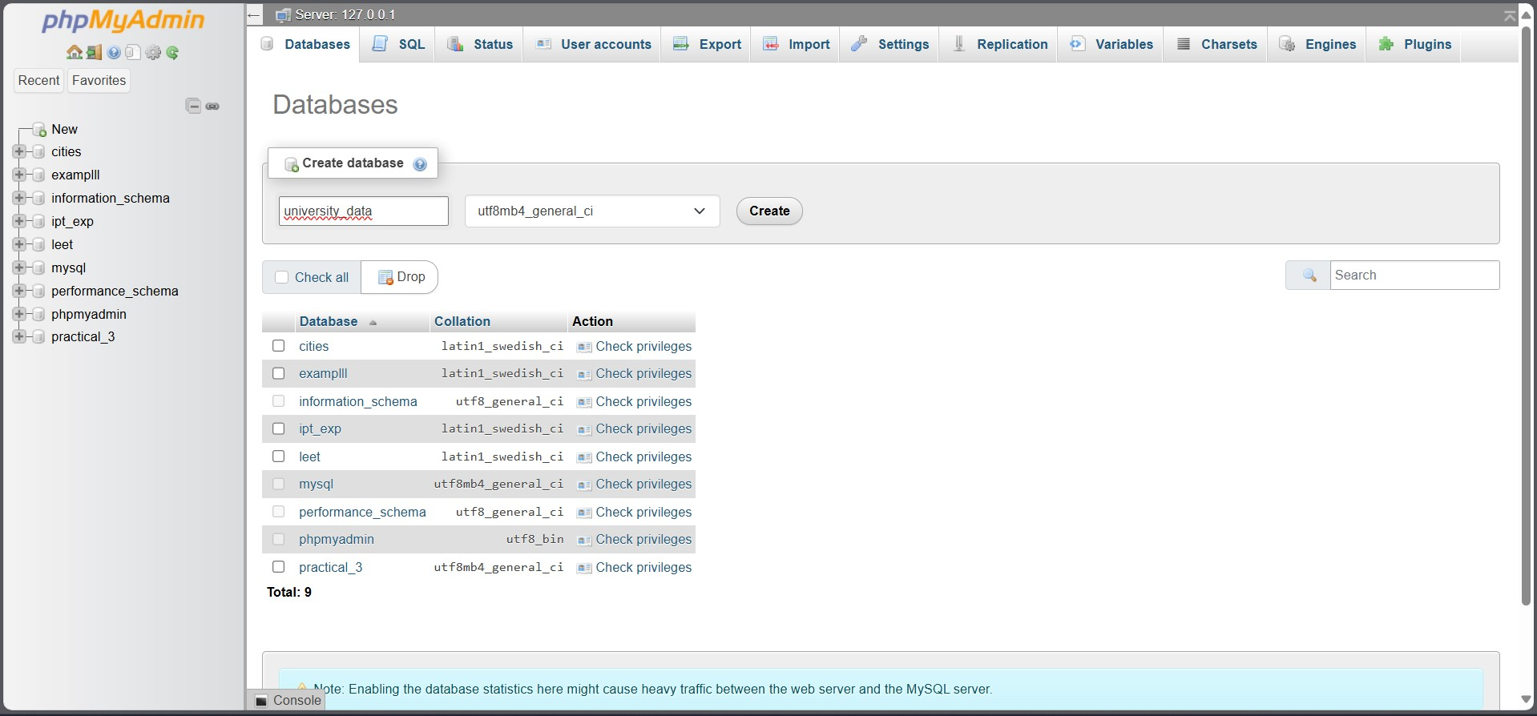

And then click on go.

1. Go to the Import tab on the top and import the university database

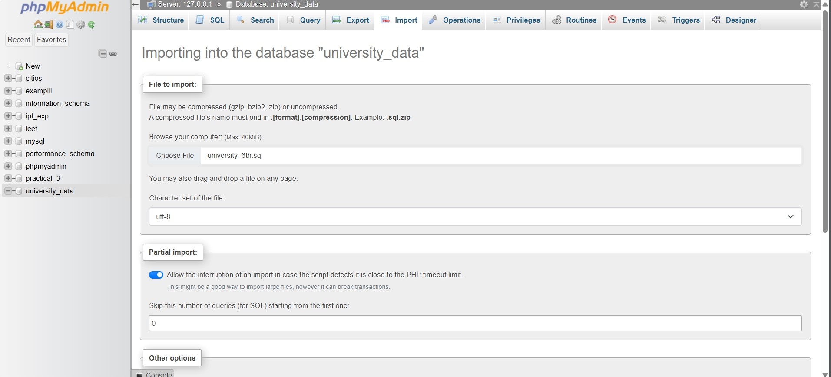

Scroll to the bottom and click on “Import” button. This will import the dataset that we will be performing our operations on.

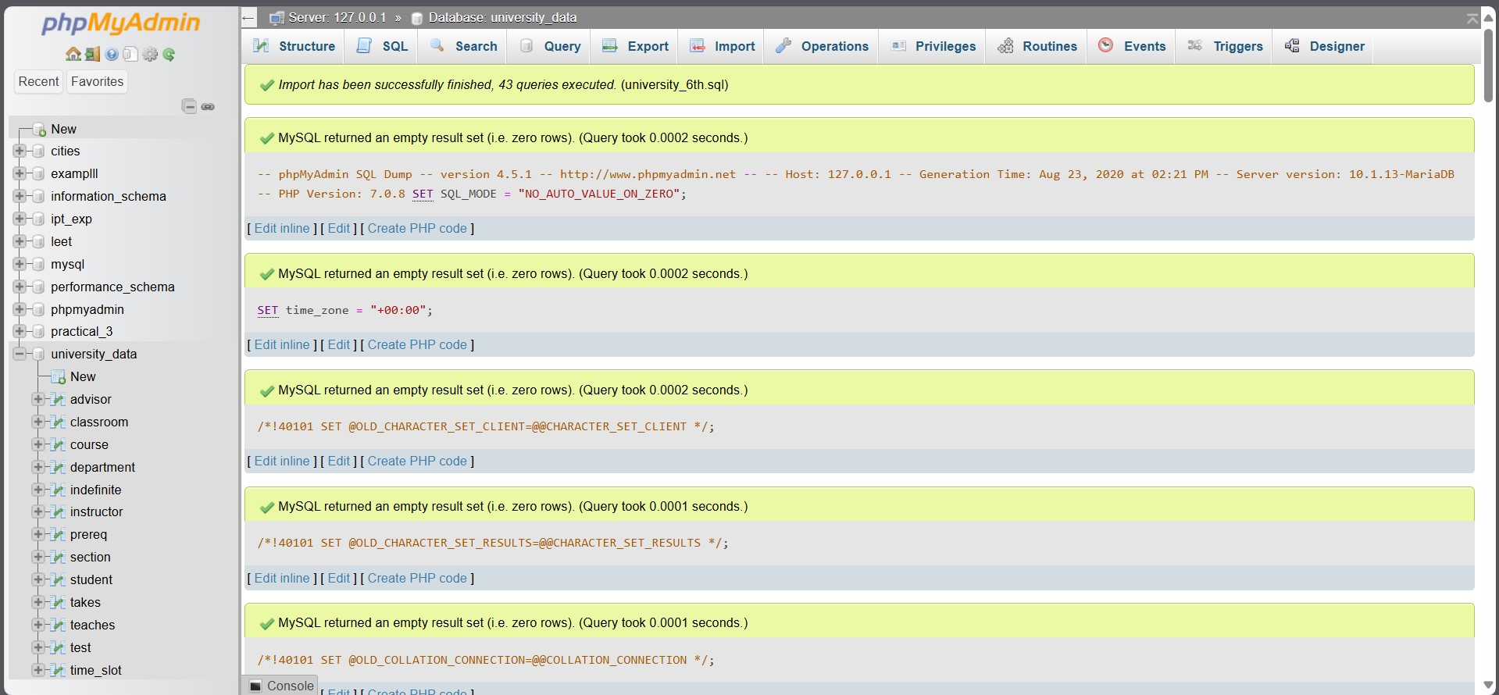

1. Let us choose any table from this dataset to modify with DELETE or UPDATE methods. For example, open the course table.

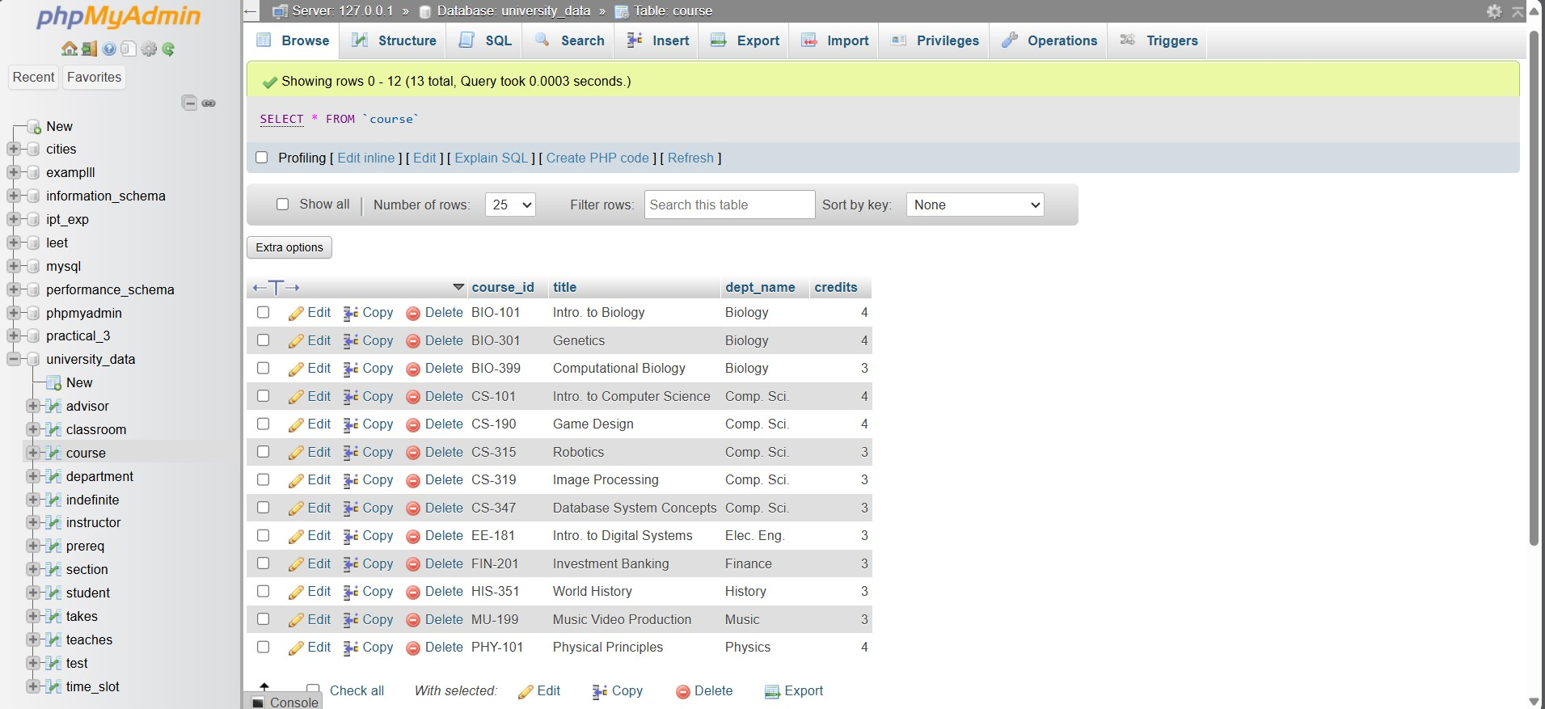

Let us double the credits for every course that is under the department of computer science. To do so open the SQL tab from the top and type in the following code to double the credits

**QUERY 1 :**

UPDATE course

SET credits = credits * 2

WHERE dept_name = "Comp. Sci.";

Here we use the “UPDATE” keyword on the “course” table, we use the “SET” keyword to set credits to double their value, with the constraint using the “WHERE” keyword

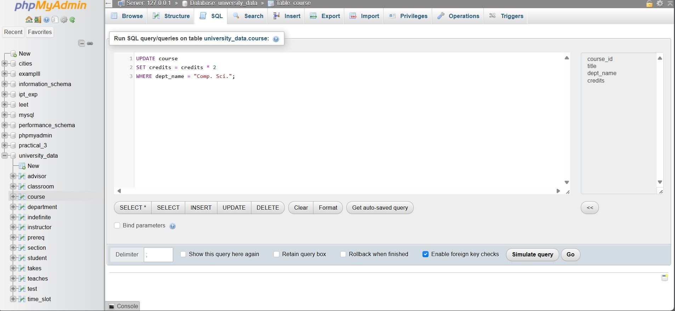

Click on the “Go” button on the bottom right to execute the query

Go to the Browse Tab to view the updated table

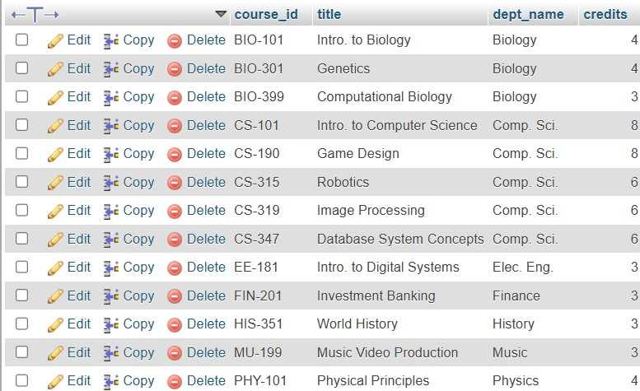

Here the credits for Comp. Sci. have been increased to double their initial value

1. Similarly to perform the deletion of tuples, let us go to “classroom” table

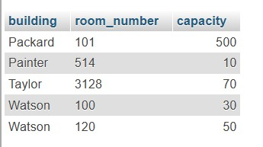

Let us delete all classrooms where the capacity is less than or equal to 50

The query to do so is

**QUERY 2 :**

DELETE FROM classroom

WHERE capacity <= 50;

Here we use the “DELETE” keyword on the “classroom” table and use the “WHERE” keyword to give it a constraint for deletion of tuples

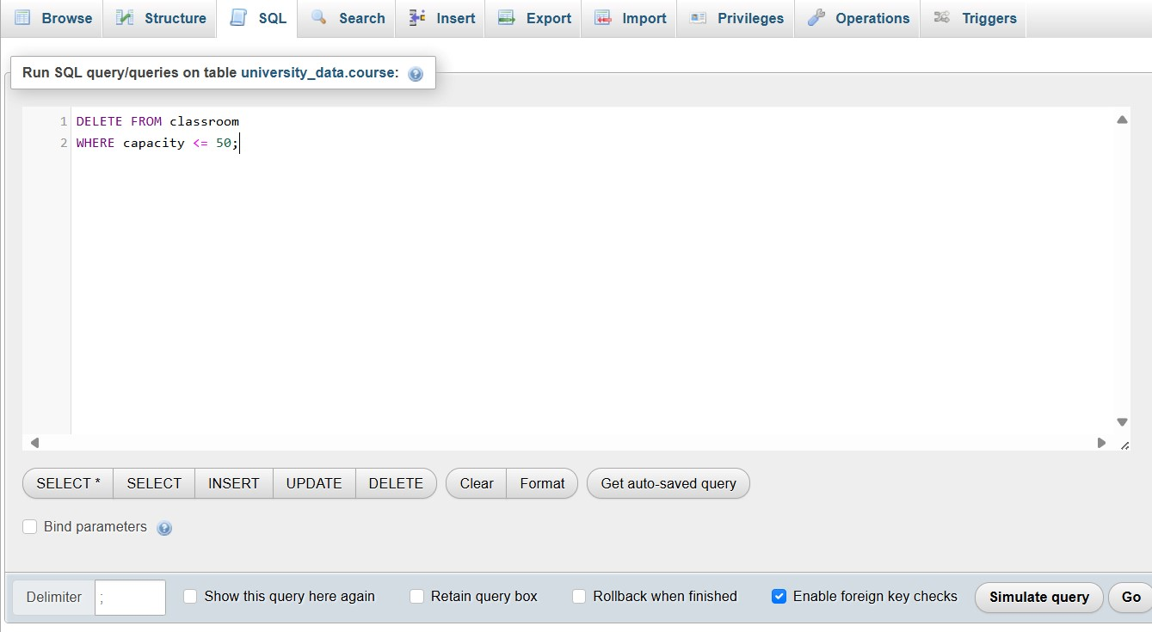

Click on the “Go” button on the bottom right.

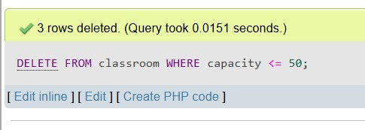

This will confirm your query is executed. To see the changes click on the “Browse” tab on the top

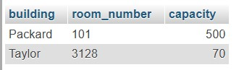

The above is the updated table with no classroom of capacity less than equal to 50

1. Some more updation queries are :

# (i) “Department” table

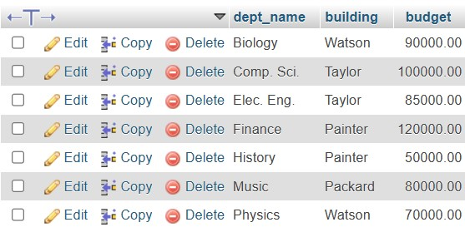

Query to half the budget for “Taylor” building

**QUERY 3:**

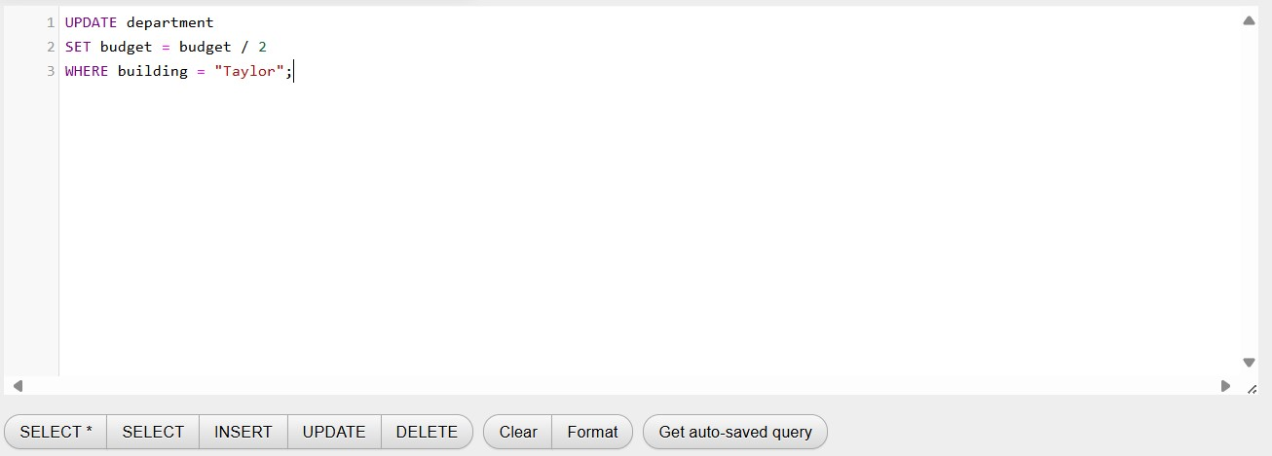

Updated table is as follows

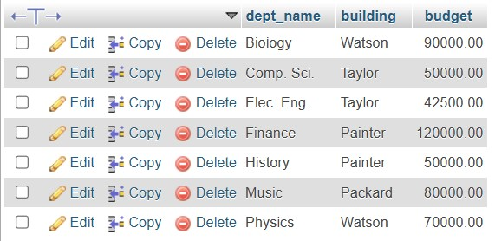

The budget reduced to half

# (ii) “prereq” table

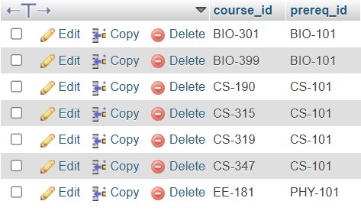

The query to delete CS-190 and its prerequisites is

**QUERY 4 :**

DELETE FROM prereq

WHERE course_id = "CS-190"

The updated table becomes

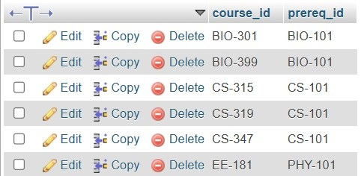

# (iii) Again “prereq” table



To update the prerequisites of BIO-301 to EVS-101, the query is as follows

**QUERY 5 :**

UPDATE prereq

SET prereq_id = 'EVS-101'

WHERE course_id = 'BIO-301';

# (iv) In the “takes” table

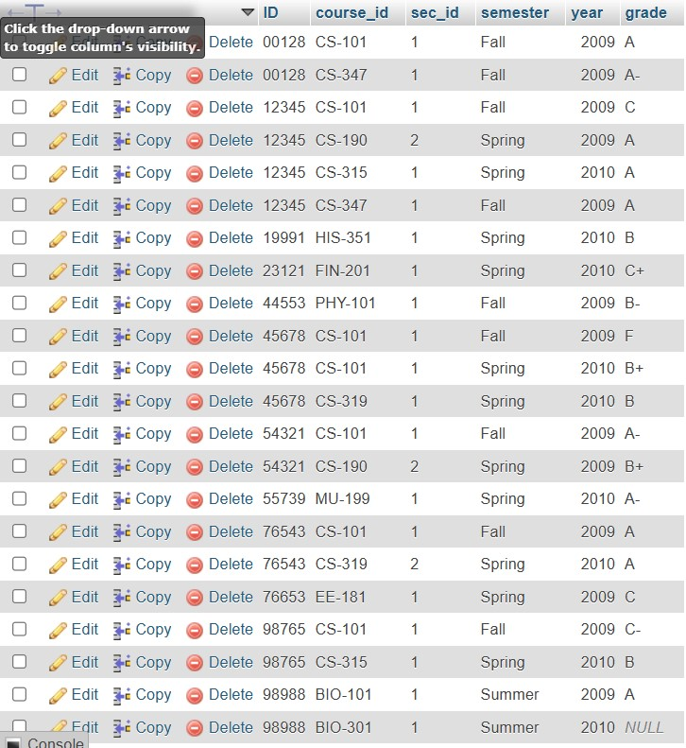

you can delete all data for ID 12345 with the query

**QUERY 6 :**

DELETE FROM takes

WHERE ID = '12345'

The updates table looks like this

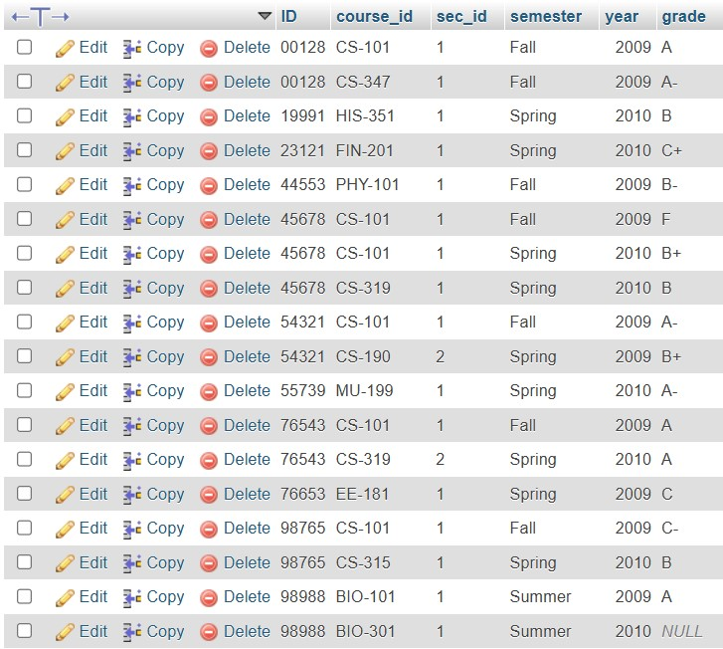

# (v) In the section table

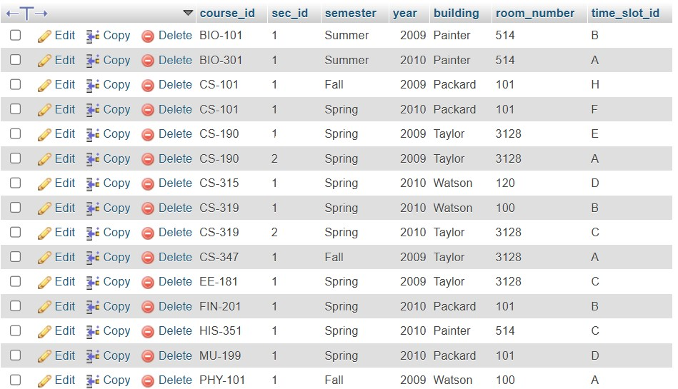

You can update the table to have sec_id be 3 when semester is sprint and time_slot_id is c

The query to do so is

**QUERY 7 :**

|  |
| --- |
| UPDATE section SET sec_id = 3  WHERE semester = "Spring" AND time_slot_id = "C"; |

And the updates table looks like this

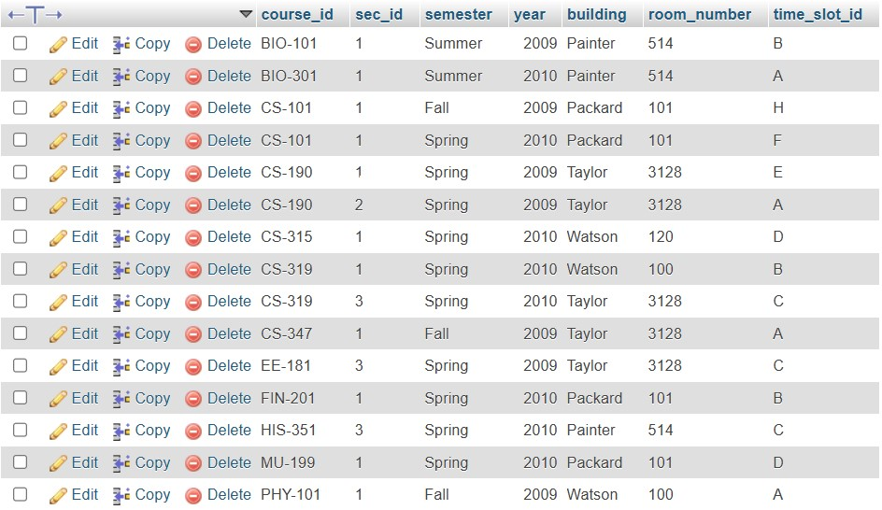

# (viii) In the instructor table

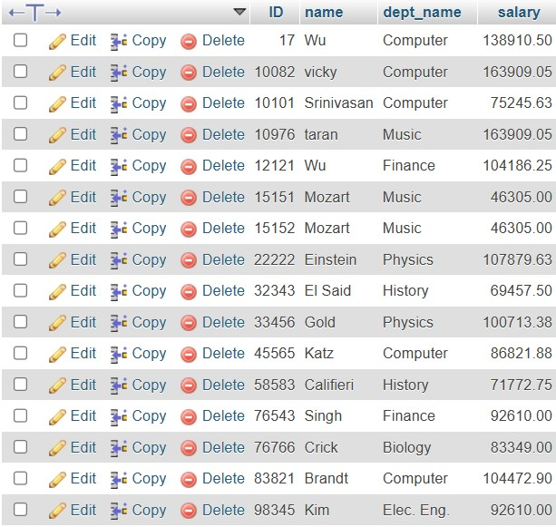

We can increase the Music department salary by 5000 using the query

**QUERY 8 :**

UPDATE instructor

SET salary = salary + 5000

WHERE dept_name = "Music";

And the updated table looks as follows

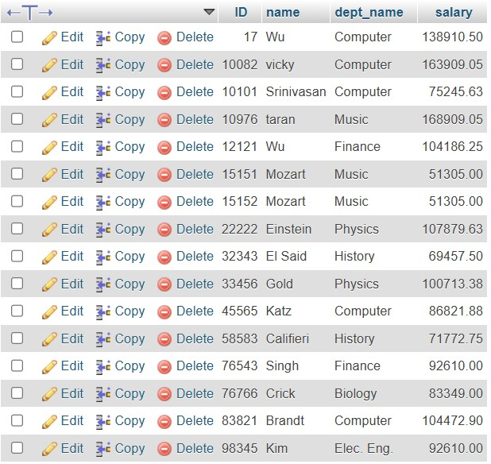

# (ix) In the section table

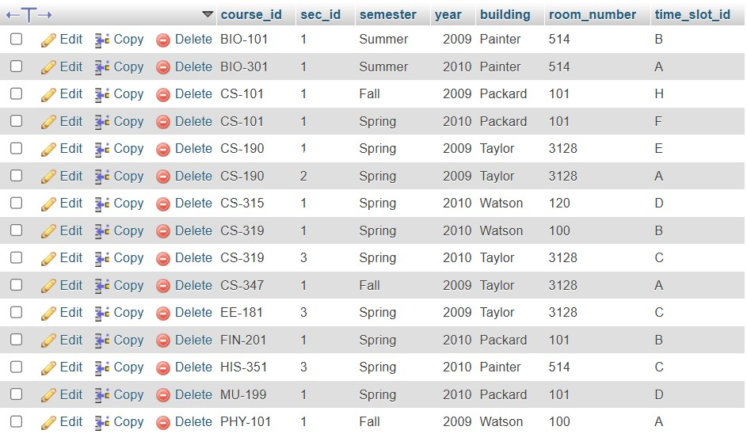

We can delete all rows where room_number is 328 with the query

**QUERY 9 :**

DELETE FROM section

WHERE room_number = 3128

The updated table looks as follows

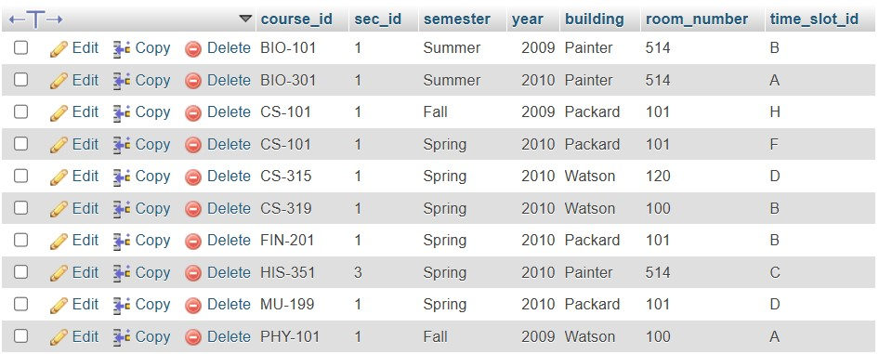

# (x) In the section table

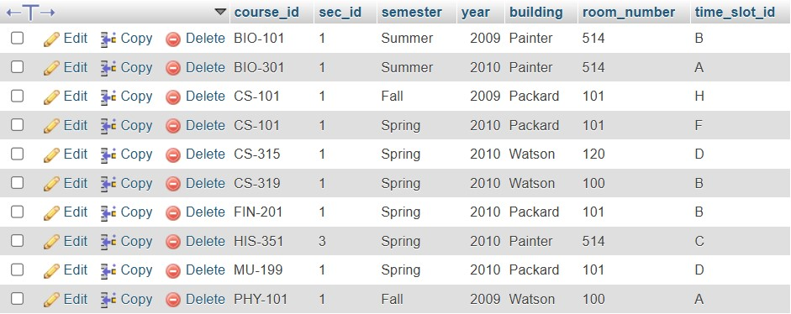

We can delete all the CS courses as follows

**QUEY 10 :**

DELETE FROM section

WHERE course_id LIKE "%CS%"

The updated table looks like so

Now we can perform the same exercise on the banking database

Start off by importing the banking database

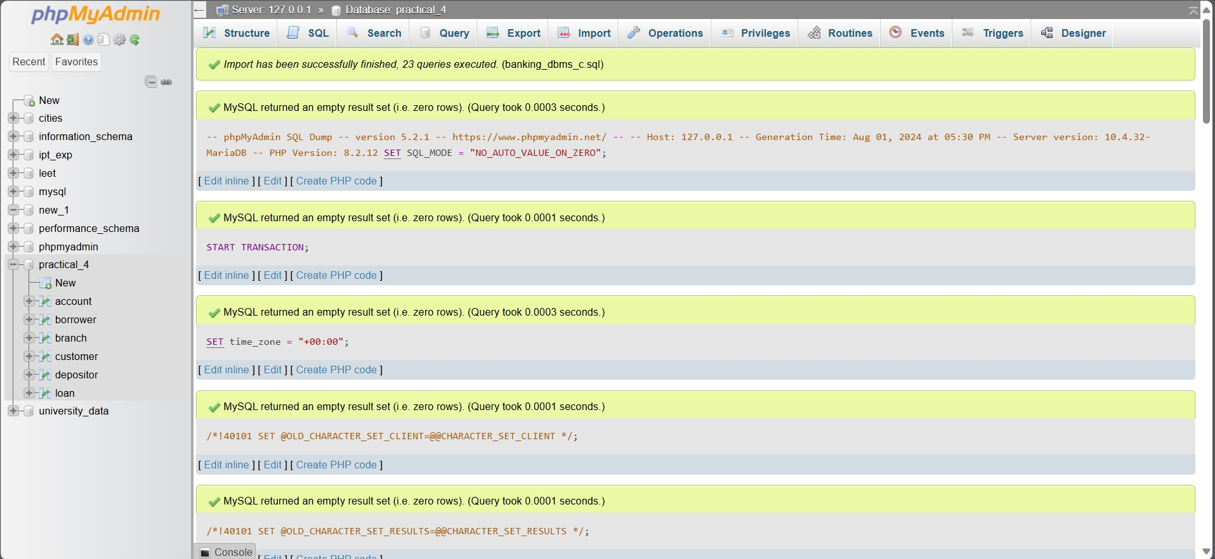

In the account table

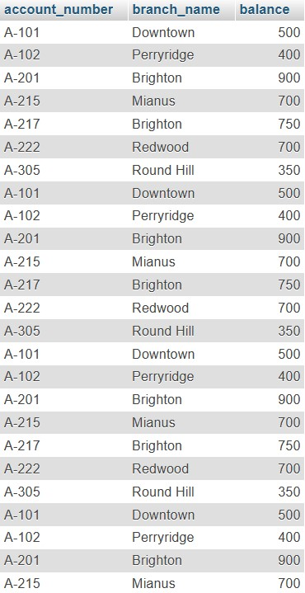

**(xi) Lets shift all account numbers in Brighton and Downtown to Southwick. The query is as follows QUERY 11 :**

UPDATE account

SET branch_name = "Southwick"

WHERE branch_name = "Brighton" OR branch_name = "Downtown"

The modified table looks as follows

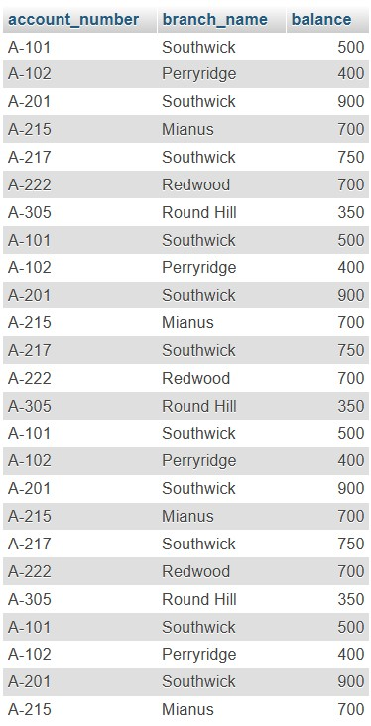

# (xii) And delete all accounts with balance less than or equal to 400

**QUERY 12 :**

DELETE FROM account

WHERE balance <= 400

The updated table looks as follows

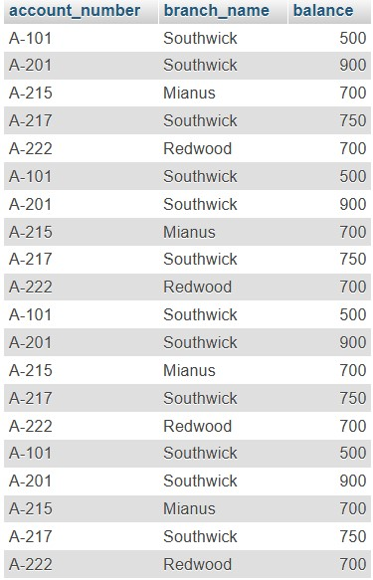

# (xiii) In borrower table

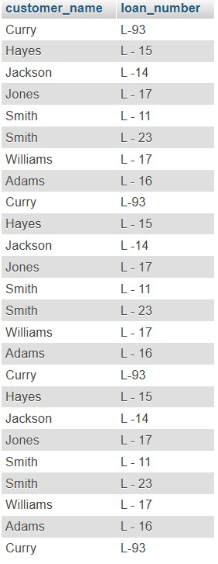

Lets delete all loans for the customer “Smith”

**QUERY 13 :**

DELETE FROM borrower

WHERE customer_name = "Smith"

The updated table looks as follows **(xiv) And update the name “Jones” to “James” QUERY 14 :**

UPDATE borrower

SET customer_name = "James"

WHERE customer_name = "Jones"

The updated table looks as follows

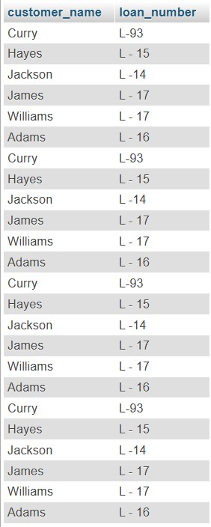

# (xv) In the customer

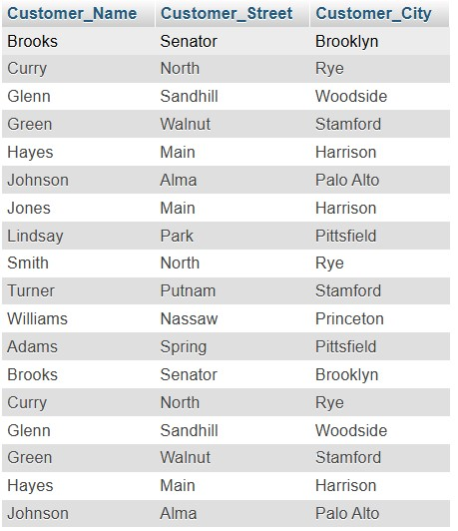

Let’s shift all customers of Senator street to Main street wit the following query

**QUERY 14 :**

UPDATE customer

SET Customer_Street = "Main"

WHERE Customer_Street = "Senator"

The updated table looks like so

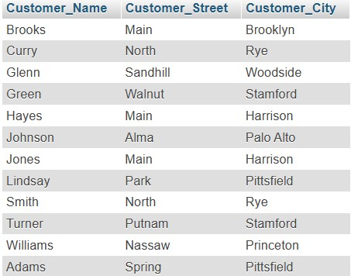

Also lets delete all accounts for customer “Curry”

**QUERY 15 :**

DELETE FROM `customer`

WHERE Customer_Name = "Curry"

The updated table looks as follows

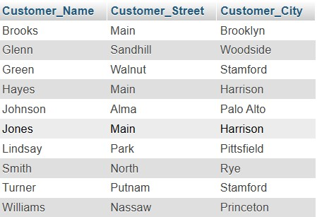

# (xvi) In the customer

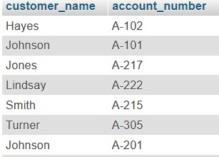

Lets delete all the customers that have the letters “es” in their name

**QUERY 16 :**

DELETE FROM `depositor`

WHERE customer_name LIKE "%es%"

The updated table looks like this

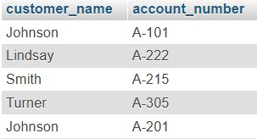

And lets update the account number of Lindsay to be A-221

**QUERY 17 :**

UPDATE depositor

SET account_number = "A-221"

WHERE customer_name = "Lindsay"

The updated table looks like so

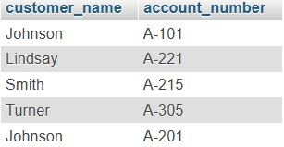

# (xvii) In the loan table

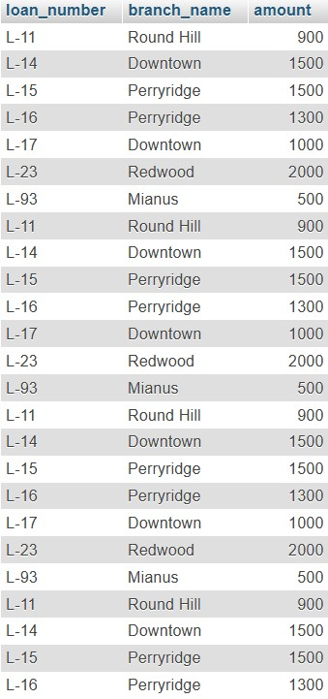

**(xviii) In the branch** Lets double the value of all assets

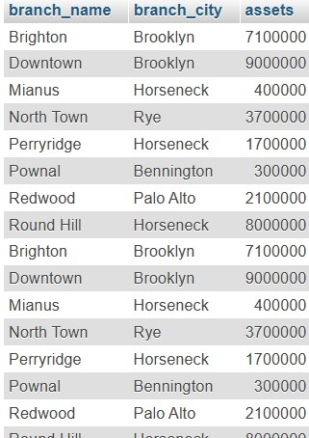

**Query 18 :**

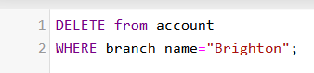

query successful

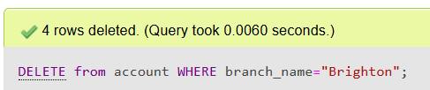

**Query 19 :**

UPDATE branch

SET assets = assets*2

The updated table looks as follows

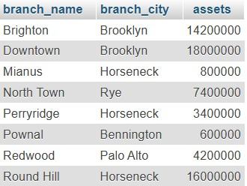

**Query 20 :**

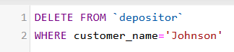

Query run successful

